Internal Scan
Executive Summary
Florida Gulf Coast University (FGCU) has demonstrated strengths with regard to faculty and staff, the quality of its academic programs, student outcomes, academic support, its physical plant, clear sense of purpose, athletics, cultural programming, civic engagement, and its commitment to environmental sustainability.
Growing enrollment while significantly reduced from historic trends is placing a strain on current facilities, funding from the state is unpredictable and competitive, sponsored research is under threat at the national level, graduate enrollment has been in decline, access to FGCU likely will become more limited, and technology staffing a constant challenge.
At the same time, opportunities exist for the development of new academic programs that meet regional and state needs, the Quality Enhancement Plan (QEP) will promote student learning and persistence, shared governance is thriving, marketing holds great promise to enhance FGCU’s national visibility, a major capital campaign is underway, and online learning holds great promise.
In summary, FGCU is positioned to leverage its strengths, address its weaknesses, and overcome all challenges as it looks to the future with confidence in its ability to continue to meet the needs of the community it serves.
Introduction
In its young history, FGCU has been highly successful by any measure. Enrollment has more than quintupled since opening day (2,584) in the fall of 1997 to 14,492 students in the fall of 2014 (as of October 14, 2014) with students representing 45 states, including the District of Columbia, and more than 85 countries. From just 49 degrees awarded in its inaugural year, FGCU now awards over 2,200 degrees annually and, during the spring 2014 commencement, FGCU’s 20,000th graduate accepted her diploma. More importantly, FGCU has risen to meet the demands of this growing population, seeing first-year retention rates increase from 43% to 78% in the fall of 2014. FGCU offers nearly 80 programs leading to a bachelors, masters or other advanced graduate degrees.
In FGCU’s first year of NCAA Division-I postseason eligibility, in 2011-12, the women’s soccer team became the first program to advance to the NCAA tournament and the softball team was the first program to attain an NCAA tournament victory. In the second year of postseason eligibility, 2012-13 the men’s basketball program became the first 15-seed in the history of the NCAA Division-I Men’s Basketball Tournament to advance to the “Sweet Sixteen”. In 2013-14 the women’s swimming & diving program finished 32nd at the NCAA Championships, women’s basketball earned their second NCAA bid in three years of such eligibility and men’s basketball claimed their initial National Invitation Tournament berth. The success of the Athletics program has helped with FGCU’s visibility and marketability on a regional and national level.
What is the underlying key to FGCU’s success? How will it position itself to continue its incredible momentum for the foreseeable future? How does the University leverage its current strengths to ensure future success? What obstacles must be overcome to realize the vision? As FGCU prepares for the next five years it is well to consider the current strengths, areas for enhancement, opportunities, and challenges that provide the context for its ambitious plans.
Strengths
Human Capital
At the heart of its success are the people that comprise FGCU: its faculty, staff and students. FGCU’s rapid growth in student numbers has outpaced increases in faculty and staff. As a result, faculty and staff are very productive. FGCU’s culture promotes faculty and staff retention and consequently results in a knowledgeable and experienced cadre of professionals to efficiently and effectively deliver the University’s programs and services.
The faculty is well-qualified and constantly growing. To ensure faculty members’ continued success, FGCU announced the establishment of the Lucas Center for Faculty Development in February of 2014. The Center is a model for other universities and will transform the University's Teaching, Learning and Assessment Initiative by expanding training and mentoring opportunities for faculty throughout their teaching careers. This commitment to faculty development will assist the University in its continued growth in academic excellence within the classroom, leading to student success and better learning outcomes. Full-time faculty provide roughly 80% of all instruction complemented by a cadre of experienced adjunct faculty. Additionally, the library staff includes 18 librarians who hold faculty rank (two of which are currently under recruitment), 4 additional professionals in technology, administration and business services, and 18.5 support staff (one of which is currently in recruitment).
Approximately 675 Administrative and Professional (A&P) and Support Personnel (SP) serve in every division of the University and are often the first points of contact at FGCU for students, parents, community members and visitors. Staff members play an integral role in the lives of students each day by supporting their development as holistically educated members of society and enhancing a variety of relevant functions including but not limited to student recruitment and retention, student engagement and success, university operations, and fundraising. The persistent efforts of staff contribute to the accomplishments at FGCU that are reflected in the key metrics by which the University is measured and are instrumental in the daily operations and public recognition of FGCU.

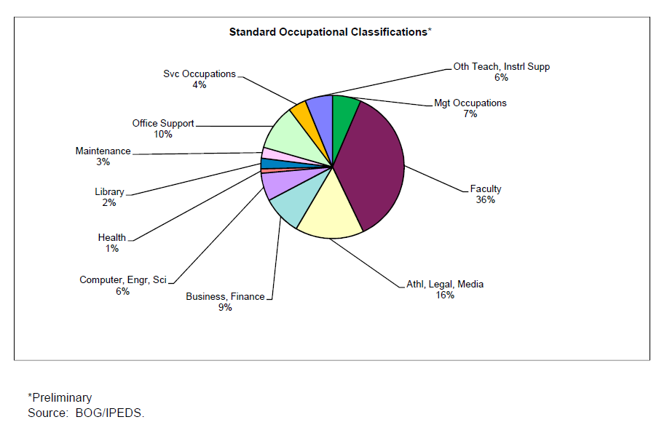
Student Enrollment & Faculty/Staff Headcount
Source: August 2014 BOTIS Report
* preliminary data

Student Services & Athletics
Student life on campus is vigorous and has grown consistently during the last decade. Over 4,700 students reside in university housing. The Division of Student Affairs provides students with new student orientation, health services, counseling, prevention and wellness programs, recreational opportunities, advising, housing, and career development to meet student needs. The Division delivers an exceptional first-year experience for residential students through its First Year Residential Experience (FYRE) program. Well-coordinated student judicial affairs and student leadership programs help round out student development.
The University’s athletic program has expanded rapidly to accommodate the growth of a regional comprehensive university. FGCU has won a combined 36 conference regular season and tournament championships in just seven years in Division I as a member of the Atlantic Sun Conference and Coastal Collegiate Swimming Association. The success of its programs and its student athletes is remarkable, and the community support the program receives is extremely gratifying. The campus is fortunate to have state-of-the-art facilities to support the program as it successfully made the transition to National Collegiate Athletic Association (NCAA) Division I. During its second year of post-season eligibility in the NCAA’s Division I, the FGCU men’s basketball team garnered national attention as the first 15th seed team to advance to the “sweet sixteen” round, all the while maintaining an average grade point average (GPA) over 3.0.
During 2013 and 2014, FGCU won regular-season Atlantic Sun (A-Sun) Conference Championships in men’s soccer, men’s basketball and baseball; as well as women’s soccer, and softball, with women’s basketball claiming its second A-Sun Tournament title and NCAA tournament berth. Student athletes also have a competitive edge academically. During spring of 2014, the average student athlete GPA at FGCU was 3.24, which was higher than the overall student body for the 11th straight semester. FGCU’s student-athletes achieved a record-tying 3.31 semester GPA and a record-breaking 3.33 cumulative GPA in the Fall of 2013. The athletic administrative staff and coaches are very experienced and professionally accomplished and, combined with the student-athletes, collectively volunteer over 5,000 hours annually in community service (6,000 plus hours in 2013-14).
Physical Plant & Grounds
The University’s state-of-the art physical plant is among the youngest in the State University System. It is characterized by low deferred maintenance and technological innovations including signature facilities for specialized fields, energy-efficient systems for cooling and electricity generation, and Leadership in Energy and Environmental Design (LEED) certified buildings. While the 800-acre campus is located on environmentally sensitive land, there is potential for growth if ecological systems and waterways continue to be carefully monitored and best practices for sustainable land management are followed.
Academic Programs
FGCU has developed and implemented a broad array of academic offerings over a short period of time. As of fall 2014, FGCU offers 52 undergraduate programs leading to the baccalaureate degree, 24 masters programs, and two doctoral degree programs (Ed.D. and D.P.T.). Many of these programs have a professional orientation and the University holds specialized accreditation from 15 different professional accrediting bodies.
Table 1. Current (2014) Specialized Accreditations
Lutgert College of Business - The Association to Advance Collegiate Schools of Business (AACSB International)
The College of Education – The National Council for Accreditation of Teacher Education (NCATE)
Master of Public Administration - Network of Schools of Public Policy, Affairs, and Administration (NASPAA)
Master of Science in Nursing Anesthesia - Council on Accreditation of Nurse Anesthesia Educational programs (COA)
Master of Science in Occupational Therapy - Accreditation Council for Occupational Therapy Education (ACOTE)
Doctor of Physical Therapy - Commission on Accreditation in Physical Therapy Education (CAPTE)
M.A. School Counseling; M.A. Clinical Mental Health Counseling; and M.Ed. in School Counseling - Council for Accreditation of Counseling and Related Educational Programs (CACREP)
B.S.N. and M.S.N. (in Nursing) - Commission on Collegiate Nursing Education (CCNE)
B.S.W. and M.S.W. (in Social Work) - Council on Social Work Education (CSWE)
Bachelor of Science in Clinical Laboratory Science - National Accrediting Agency for Clinical Laboratory Sciences (NAACLS)
B.S. in Professional Golf Management - Professional Golf Association of America (PGA)
B.S. in Athletic Training - Commission on Accreditation of Athletic Training Education (CAATE)
B.S. in Resort and Hospitality Management – Accreditation Commission for Programs in Hospitality Administration (ACPHA)
Bower School of Music and the Arts - National Association of Schools of Music (NASM)
B.S. Bioengineering, B.S. Civil Engineering, and B.S. Environmental Engineering -the Engineering Accreditation Commission of ABET
Source: Office of the Provost
These programs are particularly responsive to student and community needs as reflected in state employment data following graduation and in annual enrollment increases. FGCU graduates at both the baccalaureate and master’s levels typically are near the top of the State University System in terms of employment rates and salaries.
Workforce Development
Employment and / or Continuing Education in Florida Following Graduation  Bachelor Degrees |  |  | Employment and / or Continuing Education in Florida Following Graduation  Master Degrees
Year | FGCU’s SUS Rank |  | Year | FGCU’s SUS Rank
2005-2006 | 1 |  | 2005-2006 | 1
2006-2007 | 1 |  | 2006-2007 | 1
2007-2008 | 1 |  | 2007-2008 | 1
2008-2009 | 1 |  | 2008-2009 | 2
2009-2010 | 1 |  | 2009-2010 | 1
2010-2011 | 1 |  | 2010-2011 | 1
2011-2012 | 1 |  | 2011-2012 | 1

Source: Florida Education and Training Placement Information Program
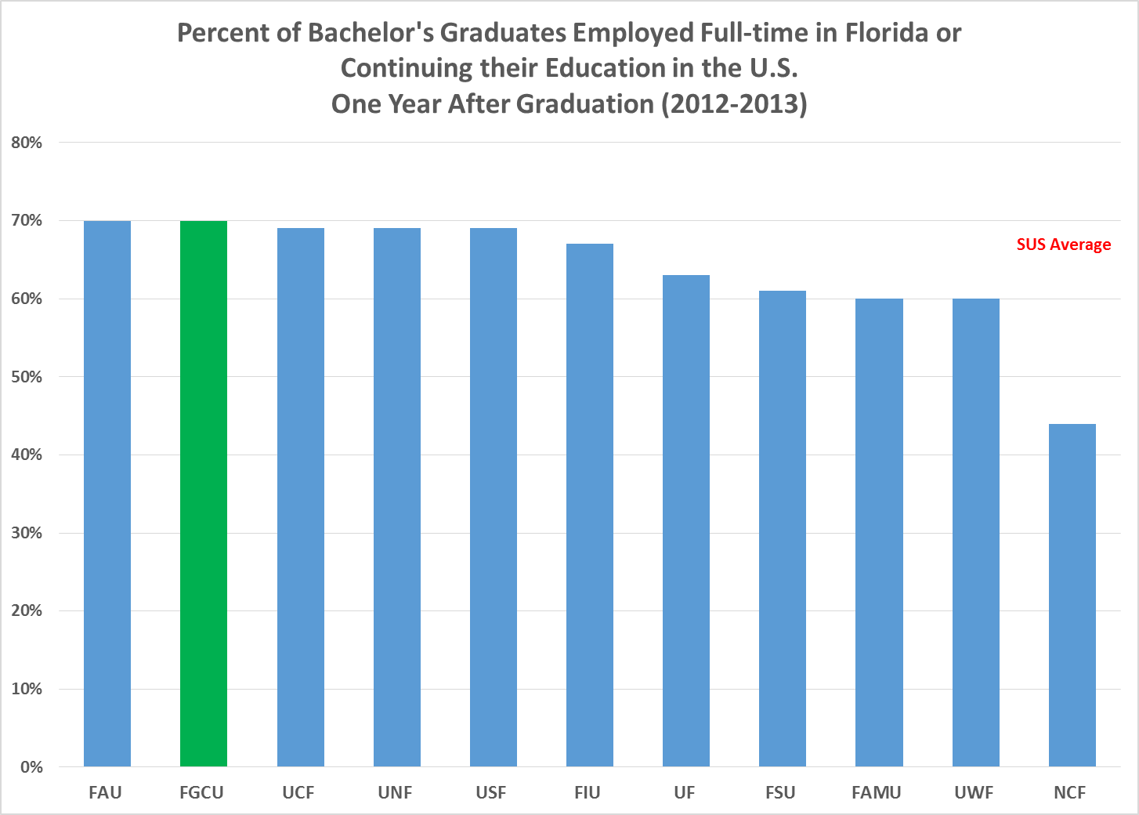
Source: Florida Education and Training Placement Information Program (FETPIP)
Community Engagement
The University’s advancement operation has been a primary strength of the University during the past decade. Successful engagement with the community has resulted in multiple public and private partnerships that significantly accelerated the growth and development of the University that simply could not have occurred with public money alone. As FGCU approaches its 20th anniversary in 2017, it has announced a $100-million fundraising campaign to ensure its continued growth and development as Southwest Florida’s leading institution of higher education. The campaign’s five strategic fundraising initiatives are Academic Excellence, Scholarships, Student Success, Athletics, and Community & Regional Impact. Together, they will positively affect the campus and the region through investments in faculty endowments and training programs; scholarly research by faculty and students; student scholarships (e.g., first generation scholarships, endowed scholarships, performance scholarships, and athletic scholarships), undergraduate learning projects, international learning projects, and career readiness projects; Eagle Funds for Excellence; funding for WGCU public radio and television; support for FGCU’s Service Learning; and expansion of lifelong-learning opportunities through the Renaissance Academy.
Renaissance Academy offers hundreds of non-credit enrichment courses. Founded in January 2001, the Academy is the University’s non-credit lifelong learning program for adults. It is based on the premise that learning should never cease; that keeping the mind intellectually, creatively and culturally active fundamentally enriches and invigorates our lives. Among the Renaissance Academy’s diverse mix of educational offerings are affordable, non-credit single lectures; short courses; day trips; computer classes; film series; life enrichment classes; writing workshops; music lessons; travel abroad programs; special events such as museum visits; private tours; distinguished scholar symposia; and discussion forums providing academic substance in an interactive format that encourages the exchange of ideas and provides both intellectual stimulation and personal enjoyment. In all of Southwest Florida, the total number of Renaissance Academy classes has grown from approximately 600 (with total registrations of 7,300) in academic year 2011-2012, to over 950 classes (with approximately 11,000 registrations) in academic year 2013-2014.
FGCU continues to stand out amongst its peers as exemplary in its commitment to community engagement and service learning. In 2014, the cumulative number of service hours contributed to the community by FGCU students rose to just under 1.6 million in approximately 350 community partner agencies since the University opened in 1997. FGCU has been recognized with placement on the National and Community Service’s Honor Roll with Distinction for three consecutive years and has been the recipient of the Campus Compact Award.
Academic & IT Support
Academic support at FGCU is exceptional. FGCU’s library services are among the great strengths of the institution. Occupying over 135,000 square feet, FGCU’s state-of-the-art library building is the on-campus focal point for student and faculty scholarship, averaging approximately 2,000 visitors per day. The library boasts 500,000 titles, 45,000 journals, 25,000 cataloged e-books, over 300 data bases, and 135 public computers, and remote access to resources is available 24/7.
The University has an outstanding Information Technology (IT) platform that is flexible and well-positioned to sustain further growth. Over 350 physical and virtual servers provide for the delivery of a broad range of applications and the University recently acquired increased bandwidth that supports greater use of technology for academic support. FGCU is an equity member of the Florida Lambda Rail (FLR), an independent research and education network aimed at facilitating advanced research and education. FLR provides opportunities for faculty members, researchers, and students to collaborate with colleagues around the world and provides access to Internet2.
FGCU’s network backbone connects all campus buildings at gigabyte speeds with 100 megabit connectivity to the desktop, with every classroom furnished with an electronic podium. Wireless computing is nearly ubiquitous on campus. Finally, courses are supported through the Canvas Learning Management system, and university business operations are facilitated through the University’s Banner software.
Auxiliary services such as the bookstore, food service operations, the Eagle ID Card System, and the R25 classroom and event scheduling system generate revenue for the University.
FGCU provides academic advising within the five academic colleges to support students in their pursuit of a degree. Between 2011 and 2014, the University hired a number of additional faculty advisors, reducing the student to advisor ratio within the colleges from over 600:1 to approximately 400:1. Additional efforts to include the creation of two positions to target advising for “super seniors” (students who have earned over 120 credit hours) were implemented in fall 2014.
Sustainability in Academics & Engagement
In support of its mission-driven focus on sustainability, FGCU participates in the Sustainability Tracking, Assessment & Rating System (STARS). STARS is a program of The Association for the Advancement of Sustainability in Higher Education (AASHE). It measures how well schools integrate social, environmental, and economic sustainability into four weighted categories: Academics, Engagement, Operations, and Planning & Administration. The report allows institutions to make meaningful comparisons over time and across higher educational sites. In 2014, FGCU received a Gold Rating from AASHE for their sustainability efforts. The chart below summarizes the findings of the report.

Source: FGCU Environmental Health and Safety
FGCU excelled nationally in the Academic and Engagement areas of the STARS report thanks to the number of courses and research including sustainability, formally adopted sustainability program learning outcomes, campus outreach campaigns, service learning, and community partnerships. FGCU scored moderately well in Operations and Planning & Administration sections due to the efficient use of energy; progressive landscape management planning; assessment of campus biodiversity; waste reduction efforts; and commitment to diversity, affordability, and shared governance. We continue the successful implementation of our signature course on sustainability, IDS 3920 University Colloquium: A Sustainable Future integrated as a requirement for all of the undergraduate programs. Students explore issues related to their own ecological perspective and sense of place and explore social, historical, economic, ecological, environmental, and political contexts of sustainability. The campus uniquely situated on conservation lands is a valuable resource as a learning laboratory, faculty regularly conduct classes and research throughout our campus wetlands and trails engaging students in hands-on Science, Technology, Engineering, and Mathematics (STEM) projects and experiences.
Student Completion
Since the time of its last internal scan, FGCU has increased native student 6-year graduation rates by four percentage point and by eight percentage points when transfer outs who graduated from other SUS institutions are considered as well. As a stated performance-based metric, FGCU continues to engage efforts to improve this percentage on an ongoing basis.
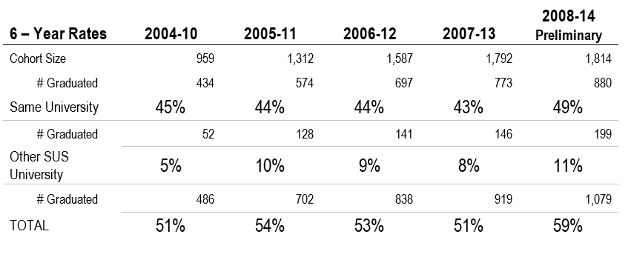
Source: FLBOG Annual Accountability Report 2013-2014
Weaknesses
Operational & Administrative Sustainability Performance
Using sustainability to guide business decisions is a proven strategy to increase an organization’s competitive advantage. In the sector of higher education, integrating sustainability into operations and administrative decision making is particularly important because it drives innovation and is linked to higher retention and graduation rates. The 2014 STARS report highlights areas for improvement, including training new and existing employees to understand the concepts of sustainability and how they relate to their daily job functions; implementing best land management and building practices; instituting green purchasing policies; decreasing water consumption; and integrating sustainability into the endowments.
Physical facilities
While the physical plant is young and has little deferred maintenance, there is a need for an additional science classroom and laboratory building to support growing instruction and research. Additionally, based on the recommendations of the State Plant Survey Team in March of 2013, there is a need for a campus recreation center and gymnasium commensurate with the size of the enrollment. The table below identifies the unmet square footage needs of facilities identified through the facilities planning Campus Plant Survey conducted in 2013.
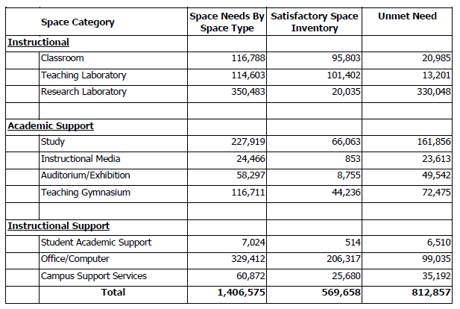
The University also identifies renovations to the chiller plant as critical to support the overall condition of the physical facilities.
Funding
Unfortunately, Public Education Capital Outlay (PECO) dollars are not expected anytime in the future. FGCU project requests for the next five years rely upon pending PECO funding, as reflected in the Five-Year Capital Improvement Plan and Legislative Budget Request excerpt from the June 17, 2014 FGCU Board of Trustees agenda item below.
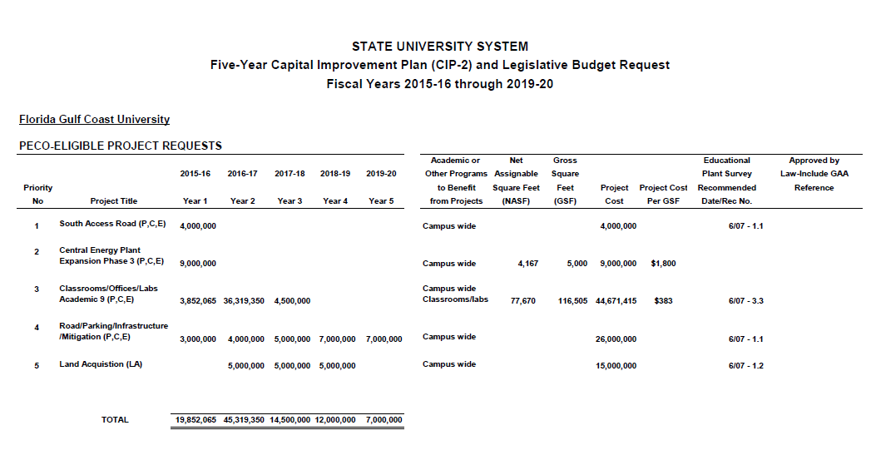
Without funding for additional facilities, opportunity for further growth is constrained. This has resulted in a less ambitious enrollment plan shown below, approved by the FGCU Board of Trustees on September 16, 2014 (original growth for in-state, undergraduate enrollment was estimated to sustain an average of 4.9% annually).
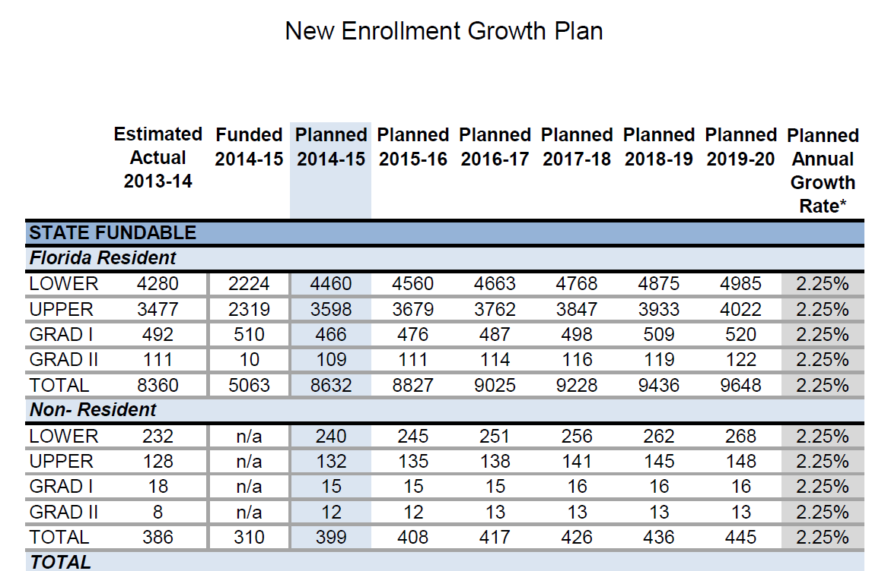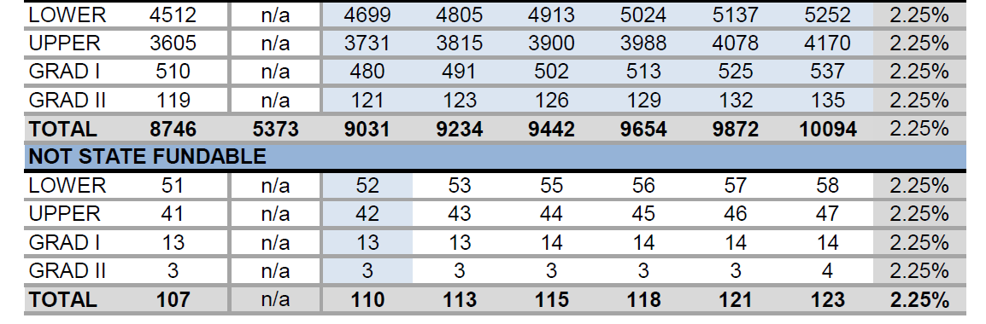
Source: Planning & Institutional Performance

The FGCU Board of Trustees has pledged to maintain a consistent tuition and fee schedule for students for two consecutive years through Regulation FGCU-PR7.001. Tuition and fee increases in the near future seem unlikely, which limits the financial revenue growth needed to support quality enhancements. For Fiscal Year 2013-2014, tuition and fees contributed close to $50 million toward the FGCU overall revenues of close to $200 million.
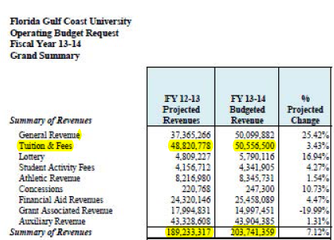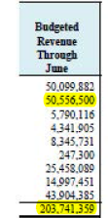
Excerpted from FGCU 2013-2014 Operating Budget

While recent years have seen an increase of four percentage points in the six-year graduation rate from 45% to 49% (see page 10) it is relatively low for the State University System. Since this metric, common to all universities in the State University System and also is tied to performance based funding, efforts are underway to address this weakness. FGCU continues to show one of the highest transfer out rates for FGCU students who ultimately earn their degree from another SUS institution. This amounted to 10 percentage points for the most recent cohort reported. In other words, FGCU’s true graduation rate including the aforementioned transfer out students is nearly 60%. FGCU needs to further enhance its reputation and broaden its program inventory to ensure able students persist rather than transfer out to graduate. The academic profile of incoming First Time in College (FTIC) FGCU students, while improving, is still below the average in the State University System.
Opportunities
Funding and Performance
Performance funding provides an opportunity to receive additional revenue. The Performance Based Funding Model includes 10 metrics, two of which are institution-specific. A number of initiatives throughout the University are targeted to improve FGCU’s performance on these metrics. Among these are the following: retention programs and services; professional development; the faculty-developed Quality Enhancement Plan (QEP) to improve student learning; support services; and data management standards to enhance operational efficiencies. The performance funding allocated to FGCU in 2014-2015 amounted to $8.1 million, of which $5.9 million was added to the budget on a recurring basis.
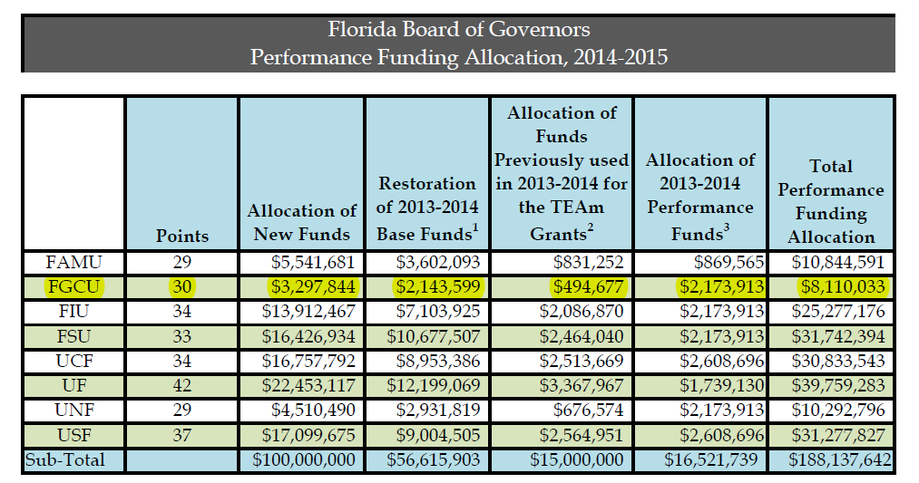

Facilities

The Campus Master Plan outlines the components for future land use, goals, objectives, and opportunities. Through 2020, the plan projects the campus core will continue to include academic functions, the library, and student services and other support functions. The southeast district will contain student housing and dining, recreation and parking facilities. The northwest district will contain research or other mixed-use facilities and associated parking. The north lakefront parcel is considered to be largely built-out, so development of this area is likely to be limited to expanded athletic facilities. The southwest district will continue to be developed with small facilities largely serving outreach functions of the University. The University will seek to acquire off-campus lands when necessary to meet the needs of academic, housing, recreation, support or ancillary units.
For fiscal year 2014-2015, FGCU was awarded $7 million to complete construction of the $12.5 million Emergent Technologies Institute (ETI), formerly known as the Innovation Hub Research and Development Park (I-HUB). The ETI will attract multiple businesses and corporations in the areas of renewable energy and sustainable environmental practices and technologies. The entire research park will be built using sustainable practices related to power generation, water runoff control, efficient building design and overall sustainability. As a manifestation of its environmentally focused mission, this project will benefit the State, and particularly Southwest Florida, as it diversifies the economic development of the region by focusing on research opportunities in fields associated with renewable energy and sustainability. The project will also expand the economic potential of Southwest Florida through further economic diversification beyond the major three-prong base of tourism, health services, and construction.
FGCU plans to construct the 24,600 gross sq. ft. ETI on a 6.5-acre parcel that has been donated to the University by developers. The 6.5-acre parcel lies within a developer-owned 240-acre tract of land to be promoted and developed as a research innovation hub. In keeping with the theme of the research park and the FGCU's mission, the ETI project will seek LEED Silver Certification.
In July 2010, FGCU received a 500-acre state property, Buckingham Complex, located approximately 15 miles from campus comprising 60 buildings totaling approximately 340,000 square feet constructed in the 1950’s and 1960’s as a comprehensive, residential medical campus. Conceptual master planning of this property is underway to assess how this property and its facilities can best be shaped to serve the mission of the University.
Online Learning
In the 2013-2014 academic year, approximately 15% of course sections offered were distance learning courses. FGCU is in a position to expand student access and quality through online learning by offering more courses and degree programs through this modality, where appropriate, and in support of the FGCU mission. An Online Learning Task Force is developing a strategic plan to guide these efforts.
In addition to the expansion of online learning options, FGCU stands to benefit from scheduling of classes to maximize utilization of existing physical facilities and increase accessibility and enrollment options for students. An analysis of classroom space utilization resulted in the expansion of courses offered on particular days of the week. The consideration of additional blended learning opportunities, whereby courses are offered as a blend of face-to-face and online learning modalities, allows for classroom space to be assigned to multiple course sections throughout a semester.
Technology Resources
FGCU has a lengthy list of technical support improvements for the Banner Enterprise Resource Package. Improvements are required to help the University keep up with growth and changing requirements for state level reporting and accreditation. Banner is a product of DATATEL + SunGard Higher Education and is a leading Student Information System used by over 2,300 colleges and universities in over 40 countries.
GULFLINE is FGCU’s name for the Banner Self-Service applications. Students can use the Self-Service applications to perform functions such as applying to the University, registering and paying for classes, viewing their class schedules, requesting transcripts, and applying for graduation. Faculty can view their classes, print rosters, and enter grades. Employees can register for benefits, view their pay-stubs, enter their timesheets, and see their leave balances. Parents can use GULFLINE to add money onto a student’s Eagle ID Card for purchases at many of the vendors, the bookstore, and printers and copiers on campus.
Banner provides built-in reports for each of the specific functional areas. Custom reports and processes are developed by the Applications Group of Business Technology Services for Banner and GULFLINE. FGCU has implemented the Cognos web-based reporting tool that pulls data from the Banner Operational Data Store (ODS), which is a transactional reporting database refreshed with data from the Banner production system daily. Cognos reports are developed by Cognos Report Authors within the functional areas and by Business Technology Services Applications Group staff. Cognos reports are published and made available faculty and staff who have been given access to view and run the reports.
Further enhancements to the integration of technology resources and systems to maximize efficiency and provide: data, process, documentation standardization, Banner customization to meet growing institutional management and external data reporting needs, and enhance communication across divisions.
New Academic Programs
Within the next five years, FGCU has proposed to add four new baccalaureate degree programs, five graduate degree programs, and two doctoral programs to its current catalog of options. These programs represent a number of degrees in science, technology, engineering and mathematics-related fields in addition to regionally relevant disciplines that address workforce needs.
Improved Student Learning
As a component of the Southern Association of Colleges and Schools Commission On Colleges (SACSCOC) Reaffirmation of Accreditation process, the FGCU faculty have proposed a Quality Enhancement Plan (QEP), “FGCU Scholars: Improving Writing, Critical Thinking, and Information Literacy in the Majors” to strengthen undergraduate student learning in relation these skills. The QEP will be integrated into all undergraduate degree programs across all levels of enrollment (freshman through senior). The ultimate goal is to improve student learning, resulting in the retention of students toward graduation and a higher caliber of FGCU graduates. This plan, upon endorsement through the SACSCOC review process, will be implemented fully in the 2015-2016 academic year.
Shared Governance
The purpose of shared governance at FGCU is to effectively promote the accomplishment of the University's unique vision and mission through shared responsibility and accountability among stakeholders, while exercising sound principles of fiscal management and retaining public accountability. FGCU is committed to the notion that the best path to success is one where the responsibility and accountability for academic excellence and student success is shared openly and cooperatively among all parties.

Implementation of shared governance at FGCU is mediated through the FGCU Board of Trustees Bylaws, Planning and Budget Council Bylaws, Collective Bargaining Agreement, Faculty Senate Governance Document, Staff Advisory Council Bylaws and the Student Government Constitution. FGCU Policy 2.012 further outlines the purpose and commitment of the University to this practice.
Marketing
In 2014, Neustadt Creative Marketing conducted a marketing study and provided recommendations on communications strategy and marketing steps to FGCU administrators. Historically, marketing initiatives at FGCU have been decentralized and inconsistent in terms of brand, messages, and integration of efforts. A newly developed organizational structure will provide for consistent policies and procedures for marketing across the University, integration of communication efforts, and creation of a collaborative and planned approach to publicly represent FGCU internally and externally. These efforts will provide opportunities for greater alumni outreach, prospective student recruitment, and donor interest.

Challenges
Degree Production
FGCU is faced with the challenges of increasing degree production with the leveling off of enrollment growth. Increasing degree production will be more dependent upon enhancing persistence to graduation. Changes to funding incentives, such as Bright Futures, and the elimination of grants have impacted student ability to finance education. Students consistently self-identify financial hardship as a reason for withdrawal from the University.
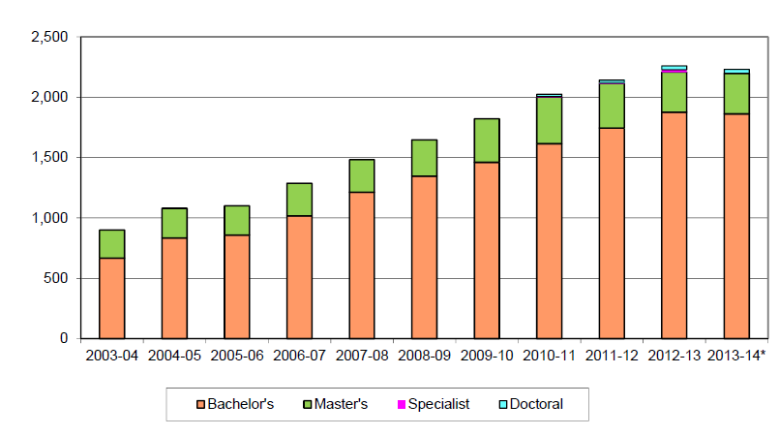
Source: Degree Production- Table 1.9 BOTIS Report August 2014
Funding
Anticipated lack of funding for capital projects will continue to pose a challenge to campus improvement and expansion efforts. University students pay Building Fees and Capital Improvement Fees of $6.76 per credit hour per semester; however, the commitment to maintain a stable tuition and fee rate, and the decrease in enrollment projections, limits future growth of this source of funding. Projects funded from this student-based source are primarily student-related and typically include outdoor recreation facilities, athletic facilities and student leisure spaces. The existing Campus Recreation Center is inadequate and needs to be expanded. The need for additional classroom, laboratory and chiller plant facilities will remain.
The continued reduction in State appropriations, resulting in the heavier reliance upon tuition and fees to support the operating budgets of the universities, presents a long-term challenge, especially with a decrease in enrollment projections. The University Board of Trustees’ continued freeze on tuition increases for FGCU students, combined with this lower projection of student enrollment growth, has the ability to impact sustainability of current programs and services.
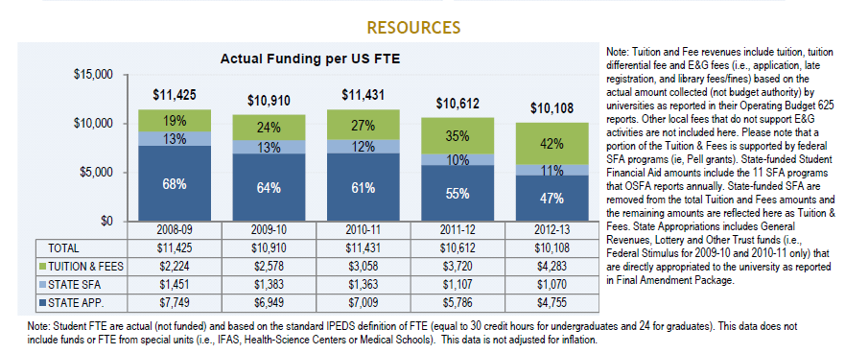
Source: Board of Governors 2012-2013 SUS Annual Accountability Report (January 16, 2014); SUS Funding
Additionally, the surrounding commercial areas bordering FGCU’s campus continue to expand. While this provides additional options for students off-campus, it minimizes the revenue generated by auxiliary services on-campus. A reduced revenue stream could cause a negative impact on bond ratings.
Sponsored research is becoming more competitive against a shrinking pool of federal funds.

Source: Office of Research & Sponsored Programs
Access
Increasing the selectivity of the University and limiting enrollment due to space constraints may lead to reduced opportunities for prospective students. The number of undergraduate applications received for the 201 4-2015 year exceeded the previous year by 24%. Additionally, the average freshman profile had a high school GPA of 3.68 (up from 3.40 in 2012-2013). Programs and services are tasked with retention of these students.
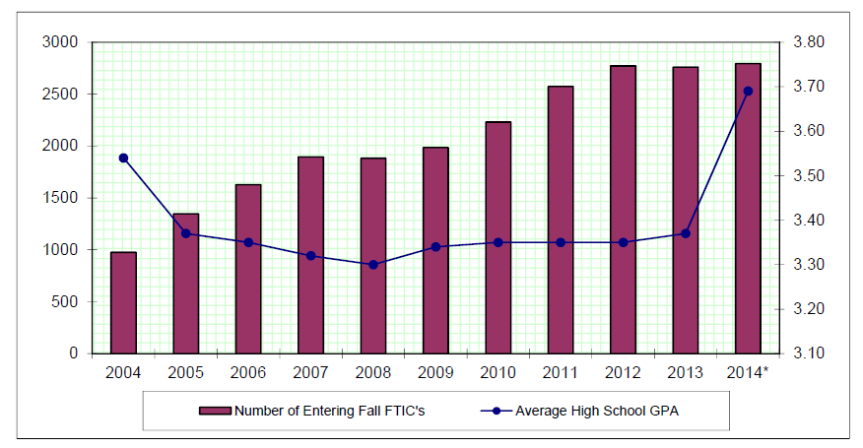
Source: FGCU Board of Trustees Information System Report
Although the total number of undergraduate applications has increased, FGCU has seen a decline in regional transfer students from the nearest State College System institution, in large part, due to the establishment of baccalaureate programming in workforce-oriented disciplines (to include education, nursing, and management). As a result, students who traditionally selected FGCU as their transfer institution of choice due to location, connection to the community, and inability to relocate for continuing education, have alternate cost-effective options within the FGCU region.
FGCU has the second highest out-of-state undergraduate tuition rate, and the highest out-of-state graduate level tuition rate, within the State University System (respectively $838.73 and $1,232.40 per credit hour in 2014-2015). Tuition and fees are prohibitive to many out-of-state students, making it somewhat challenging to recruit students who have not yet established Florida residency or who are residents outside of Florida. Out-of-State students add diversity and enhanced selectivity to the student body and have the potential to increase institutional revenue at a time of constrained revenue growth.

Technology Resources
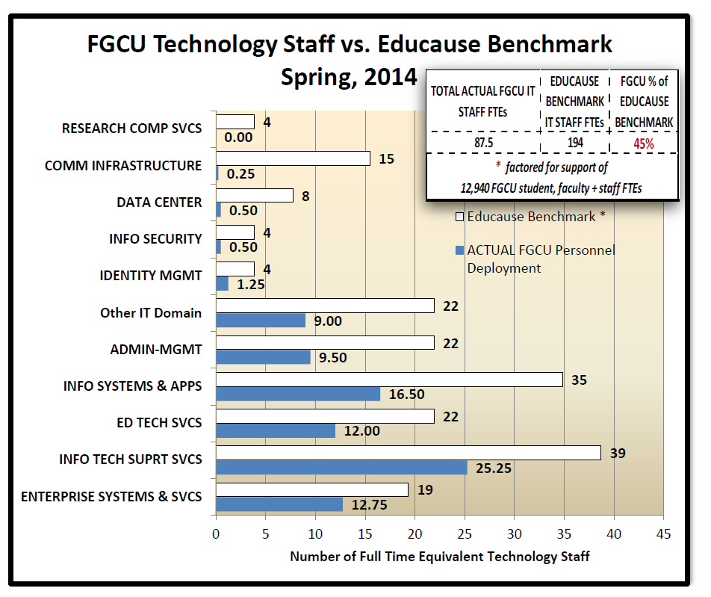
Although the information technology infrastructure at FGCU represents an inherent strength, the number of IT staff is not large enough to sustain the current level of IT services specifically in the areas of information security, information systems and applications, and educational technology and services. Retention of IT staff should also be considered.
Source: Information Resource Committee of the Planning and Budget Council.
Summary
As reflected throughout the Internal Scan, FGCU has many accomplishments to celebrate, strengths to promote, and opportunities to pursue and capitalize upon. However, it is necessary to recognize the current and future challenges that may pose a threat these endeavors. New initiatives, enhanced marketing, identification of funding sources, and retention of stronger students provide a positive foundation for these efforts. As FGCU prepares for the next five years it will consider all of these factors that provide the context for its ongoing plans.

